TEAM MEMBERS DETAILS

Empathy Map

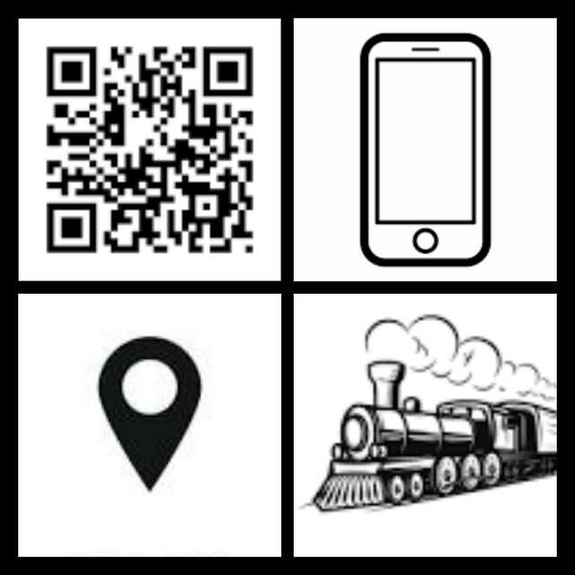

To Avoid Time Consumption

To Avoid having to carry Proof Documents

Create a Database for Individual Users

To Avoid the Printing Tickets

To Avoid waiting

in a Queue

Unique ID

is used to store booking details.

Database stores user information.

Shows available seats for booking.

Scan the QR Code to Verify

No Paper

Consumption

In order to Avoid Lost of Ticket

All details are retrieved back from Unique ID.

Monitor Live Location

Access all passengers' details

In an emergency, use personal information.

Advanced and Secured Ticket Booking

Generate a QR code for Booking

Scanned

QR Code Process

Install GPS Module in Train

Design a Website or Application

|  |  |  |  |
| --- | --- | --- | --- |
| S.NO | NAME | DESIGNATION/DEPT. | COLLEGE NAME |
| 1 | NEGADHARSHINI B | TEAM LEADER /ECE | JAYALAKSHMI INSTITUTE OF TECHNOLOGY |
| 2 | ARCHANA S | TEAM MEMBER 1 /ECE | JAYALAKSHMI INSTITUTE OF TECHNOLOGY |
| 3 | MAHALAKSHMI R | TEAM MEMBER 2 /ECE | JAYALAKSHMI INSTITUTE OF TECHNOLOGY |
| 4 | THAMBIDURAI P | TEAM MEMBER 3 /ECE | JAYALAKSHMI INSTITUTE OF  TECHNOLOGY |

OF

**NEED STATEMENT**

*NEEDS A WAYS TO SO THAT*

OUR JOURNEY MIGHT NOT BE AT RISK

ONLINE BOOKING & TRACKING LOCATION

SMART RAILWAY

OUR JOURNEY WILL NOT BE AT RISK BY USING SMART RAILWAY APPLICATION